Paper Title for
Indonesian Journal on Geoscience
(Up to 15 words, Times New Roman 12, space 1)

[Author(s):] ¹Authors Name/s per 1st Affiliation (Times New Roman 11, space 1)
[Affiliation:] ¹Dept. name of organization, (Line 1 of Affiliation - optional) City, Country
(Times New Roman 10, space 1, spacing after 6 pt)

[Coresponding author]

[Abstract] - The abstract should be written in English, clearly and concisely, summing up the article theme and does not need to contain a detailed summary from each part. Basic guidelines for the preparation of a technical work for Indonesian Journal on Geoscience are presented. It must provide the reader with a self-contained summary of the paper. It should include a brief introduction to the paper, method, key findings, and conclusions. The abstract is limited to 250 words and cannot contain equations, figures, tables, or references. It should concisely state what was done, how it was done, principal results, and their significance.
[Keywords] 4 - 7 words of keywords should be written below the abstract, singular or a compound word, for indexation (should not words that are used in your article’s title).

[INTRODUCTION]

Background
This part must consist of a comprehensive description, so readers will understand and can evaluate the research result that has been done without reading another publication/article. The introduction must consist of background, aim and objective, problem, research location, and research subject. Manuscripts should comprise original, unpublished material and not submitted for publication elsewhere.
Paper submitted is accepted to be process, if it has not been submitted or published elsewhere and become copyright of the Indonesian Journal on Geoscience. Paper is also accepted on the understanding that all authors consent to the submission. Please ensure that all authors have seen and approved the submitted version.

Geological/Stratigraphical Settings
Geological information, both regionally and locally should be explained, including tectonics and structures if neccessary. Stratigraphy of the studied area is also important to describe.

[METHODS AND MATERIALS]

Methods
If the manuscript is a result of a geoscientific research, the research methods used including how to collect samples, type of samples, field and laboratory instruments and equipments used, and data analysis framework must be explained and described. Important analyzed data results can be presented as attachments. Moreover, theories and concepts used may be included within this heading. If the manuscript is a geoscientific review, its basic framework should be explained.

Materials
Material need in the study, both field and laboratory works, such as types and total number of samples should be described.

[RESULT (AND ANALYSIS)]

Words, Tables, and Figures
The result and analysis are composed of a research result as displayed as words, tables, and figures. Please use limited graphics if the subject can be displayed as a short explanation. The limitation of using photo as figure will be appreciated. It needs to be displayed if it can describe a better explanation for the research result. All of figures and tables should be given continuing numbers and must be referred in the article.
Large figures and tables may span both columns, but may not extend into the page margins. Figure captions should be below the figures; table captions should be above the tables. Do not put captions in "text boxes" linked to the figures. Draw borders around your figures.
All figures and tables must be numbered and put in place in the text near, but not before, where they are first mentioned. Do not use the abbreviation "Fig. 1," for figure, or “Tab.” for Table.
Digitize your tables and figures. The figures (including photographs) must be in Image File (*.jpg) with minimum 300 dpi in resolution, Corel Draw (*.cdr), or Auto Cad (*.dwg). Figures and tables should be better put at the end of the article in separate page/s. Permission from the original author is required to display figures and tables that have been published.
It is essential that all illustrations are clear and legible. Vector graphics (rather than rasterized images) should be used for diagrams and schemas whenever possible. Please check that the lines in line drawings are not interrupted and have a constant width.
Grids and details within the figures must be clearly legible and may not be written one on top of the other. Line drawings are to have a resolution of at least 800 dpi (preferably 1200 dpi). The lettering in figures should not use font sizes smaller than 6 pt (~ 2 mm character height).
Table 1. Average Fault Oientations recognized from Setreographic Analysis of Structural Domains along the HEAT and Grassberg Roads (Source: IJOG, vol. 3 no. 1)

Fault Type |  | D1 | D2 | D3 | D4 | D5 | Clay Cake Model
Dextral |  | 001º/85º | 005º/69º | 184º/81º | 003º/72º | 011º/80º | R’
Sinistral |  | 057º/80º | 053º/78º | 054º/74º | 082º/80º | 075º/79º | R
Sinistral |  | - | - | - | 102º/79º ? | - | P
Dip-slip | a | 101º/70º | 109º/66º | 098º/63º | 298º/81º | 317º/80º | N/T
Dip-slip | b | 205º/85º | 203º/80º | - | - | - | N/T
(*)Fracture sets are interpreted by comparison to physical model results of clay cake experiments by Riedel (1929) and Rchalenko (1970). R = Riedel shear fracture, R’ = conjugate Riedel shear fractures, P = P-shear,
N = normal, and T = thrust (Sapiie, 1998).

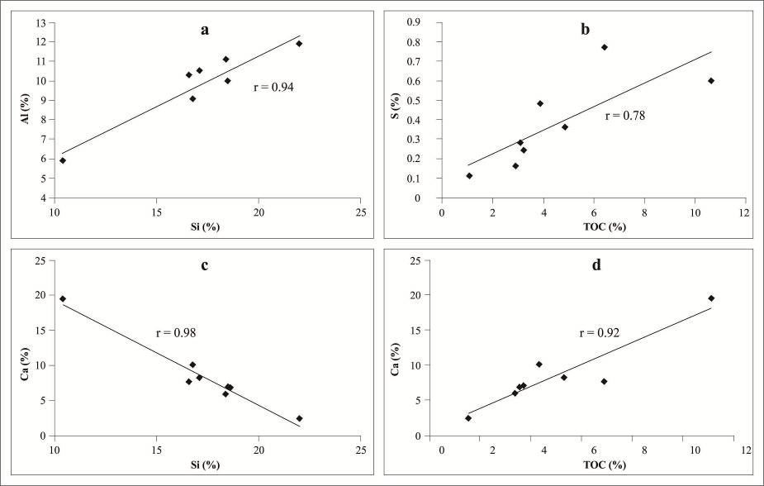

Figure 6. Plots of major elements of the Sangkarewang oil shales. a. Si vs. Al; b. TOC vs. Si; c. Si vs. Ca; d. TOC vs. Ca (Source: IJOG, vol. 2 no. 3).

Math and Equations
Use either the Microsoft Equation Editor or the MathType commercial add-on for MS Word for all math objects in your paper (Insert | Equation or MathType Equation). "Float over text" should not be selected.
To make your equations more compact, you may use the solidus ( / ), the exp function, or appropriate exponents. Italicize Roman symbols for quantities and variables, but not Greek symbols. Use a long dash rather than a hyphen for a minus sign. Use parentheses to avoid ambiguities in denominators.
Number equations consecutively with equation numbers in parentheses flush with the right margin, as in (1). Be sure that the symbols in your equation have been defined before the equation appears or immediately following.
$I_{F}=I_{B}=−I_{C}=A^{2}I_{A1}+{\text{AI}}_{A2}+I_{A0}=\frac{−J\sqrt{3}E_{A}}{Z_{1}+Z_{2}} \left(1\right)$where I_{F} is the fault current.
Use "(1)," not "Eq. (1)" or "equation (1)," except at the beginning of a sentence: "Equation (1) is .…"

[DISCUSSION]

The discussion consists of an interpretation of the result and analysis. It should be correlated with another result having been reported. To obtain clear and concise discussion and to solve the problem of the research, supporting figures/maps/graphics/photos are required.

[CONCLUSIONS]

They comprise important conclusions within the whole part of article, and must be related to abstract content. It can be written as full sentences or pointers.

[ACKNOWLEDGMENTS]

This part may describe the source of research fund used in the research. This may also give an appreciation to institutions or persons who help in research and report writing.

[REFERENCES]

References are important to the reader; therefore, each citation must be complete and correct. There is no editorial check on references; therefore, an incomplete or wrong reference will be published unless caught by a reviewer or discusser and will detract from the authority and value of the paper. References should be readily available publications.
If a reference is available from two sources, each should be listed as a separate reference. Give all authors' names; do not use et al. and number. It must all be cited in the text and support the content; written using modified Harvard System alphabetically.
Some samples of the correct formats for various types of references are given below.

Journal
White, P.S. and Pickett, S.T.A., 1985. Natural disturbance and patch dynamics: An Introduction. In: Picket, S.T.A. and White, P.S. (eds.), Natural Disturbance and Patch Dynamics, Academic Press. San Diego, California USA. DOI: 10.1016/B978-0-12-554520-4.50006-X
Book
Diessel, C.F.K., 1992. Coal Bearing Depositional Systems. Springer-Verlag, Berlin, 721pp.
Book Section
Costa, J.E., 1984. Physical geomorphology of debris flow. In: Costa, J.E. and Fleisher, P.J., (eds.), Developments and Application of Geomorphology. Springer-Verlag, Berlin, p.268-317.
Abstract
Barberi, F., Bigioggero, B., Boriani, A., Cavallini, A., Cioni, R., Eva, C., Gelmini, R., Giorgetti, F., Iaacarino, S., Innocenti, F., Marinelli, G., Scotti, A., Slejko., Sudradjat, A., and Villa, A., 1983. Magmatic evolution and structural meaning of the island of Sumbawa, Indonesia-Tambora volcano, island of Sumbawa, Indonesia. Abstract 18th IUGGI, Symposium, 01, p.48-49.
Map
Simandjuntak, T.O., Surono, Gafoer, S., and Amin, T.C., 1991. Geological Map of Muarabungo Quadrangle, Sumatera, scale 1:250.000. Geological Research and Development Centre, Bandung.
Proceedings
Suwarna, N. and Suminto, 1999. Sedimentology and Hydrocarbon Potential of the Permian Mengkarang Formation, Southern Sumatera. Proceedings, Southeast Asian Coal Geology, Bandung.
Thesis/Dissertation
DAM, M.A.C., 1994. The Late Quaternary evolution of The Bandung Basin, West Java, Indonesia. PhD Thesis at Dept. of Quaternary Geology, Faculty of Earth Science, Vrije Universitet Amsterdam, p.1-12.
Unpublished Report
Bachri, S., Suminto, Satria, D., Gunawan, W., Endharto, M.A., and Susanto, E., 2001. Penelitian Stratigrafi dan Sedimentologi di Cekungan Ombilin, Sumatera Barat. Internal Report PKIGT, Geological Research and Development Centre, Bandung (Unpublished).
Information from Internet
Cantrell, C., 2006. Sri Lankan’s tsunami drive blossom: Local man’s effort keeps on giving. Http://www.boston.com/news/local/articles/2006/01/26/sri_lankans_tsunami_drive_blossoms/[26 Jan 2006].

